OUT-OF-SYSTEM INTERLIBRARY LOAN INSTRUCTIONS
for OWWL Member Library Staff
REVISED MAY 2024

Out-of-system interlibrary loans require special processing.

CIRCULATION
Special loan items have different due dates:
- Check the label for due date – there is no need to calculate additional travel time
Due Date: MM-DD-YYYY

- Upon check-out, enter SPECIFIC DUE DATE to match the date on the label and the Evergreen check-in alert message
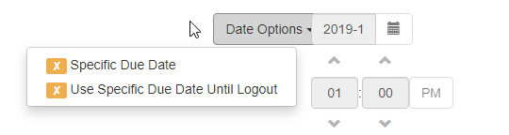
Be sure to tell the patron this special due date

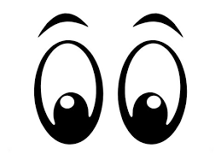

RETURN DELIVERY
Special loan items require special handling:
Secure the item in an envelope marked for OWWLHQ-ILL and place it in a delivery bin

RENEWALS
Special loan items require renewal approval:
Library staff MUST CONTACT OWWLHQ to request renewal of eligible items
OWWLHQ staff will notify the member library of the request outcome
- If approved, OWWLHQ staff will edit the patron’s due date
- If denied, the current due date will remain in effect
- If no contact is possible, you may extend the loan for 1 additional week only
  - Be sure to email ill@owwl.org with this information
Member library staff will need to notify patron of the renewal status (approved or denied)

Questions? Contact Kathryn Riedener at ill@owwl.org

